Assignment – 02

Name : Akash Sunil Hedaoo
Class / div : IT – B3
Subject : Computer Networks
Roll no : 55
PRN : 121411761

Problem Statement: Use Socket programming to create Client and Server to send Hello message
CLIENT OUTPUT :
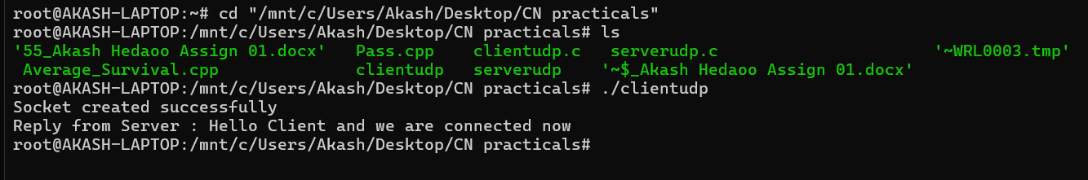
SERVER OUTPUT :
